Computer Networks 1
Lab 4
Socket Programming in Java: Chat Application

Names: Vuong Le Huy
Student No.: 1652252
I. Objectives
- Practice with Socket programming in Java
- Build a simple chat application using client-server model
- Multithreaded application in Java
II. Content
1. Socket programming in Java
Consider the following code:
try {
// Get hostname by textual representation of IP address
InetAddress addr = InetAddress.getByName("127.0.0.1");
// Get hostname by a byte array containing the IP address
byte[] ipAddr = new byte[]{127, 0, 0, 1};
addr = InetAddress.getByAddress(ipAddr);
// Get the host name
String hostname = addr.getHostName();
// Get canonical host name
String hostnameCanonical = addr.getCanonicalHostName();
}
catch (UnknownHostException e) {
}
Exercise 1:
Create a program that connects to a web server and downloads the homepage of this website to local computer.
Ex.: You can test your program with: www.google.com
2. Develop a simple chat application using client-server model
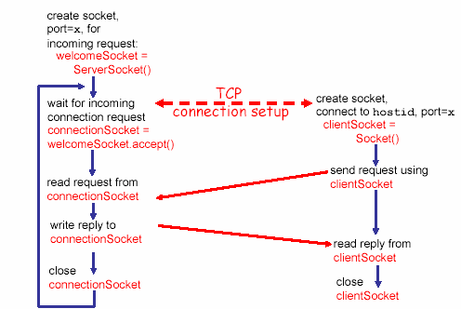

Server application | Client application
Create a server socket
Listen and wait for incoming connection request | Identify server IP and port
 | Create a TCP socket to the server
 | Establish a connection to the server
Accept the connection request
Send/Receive data | Send/Receive data
 | Close connection
Close connection
Exercise 2: Design the user interface for the chat application
3. Multithread in Java
Create an application that has multiple threads running concurrently:
1. class PrimeRun implements Runnable {
2. long minPrime;
3. PrimeRun ( long minPrime ) {
4. this.minPrime = minPrime;
5. }
6. public void run() {
7. // compute primes larger than minPrime
8. . . .
9. }
10. }
11. PrimeRun p = new PrimeRun(143);
12. new Thread(p).start();
Stop a thread:
Try to use Thread.interrupt() as in the following code and see what happens.
public void stop() {
running = false;
this.interrupt();
}
public void run() {
running = true;
while (running){
Socket s = socket.accept();
...
}
}

public void stop() {
running = false;
this.interrupt();
}
public void run() {
running = true;
while (running){
Socket s = socket.accept();
...
}
}
Multithread in Server Application:
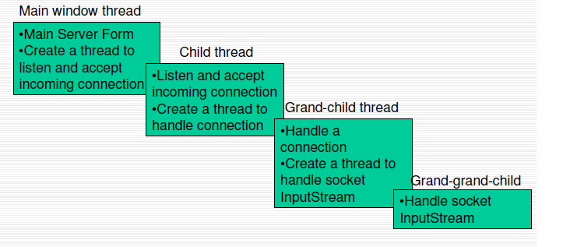
Multithread in Client Application:
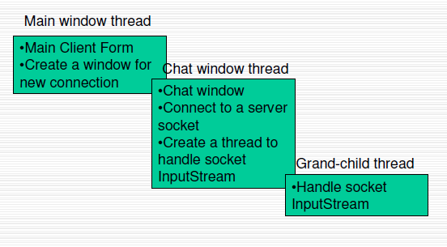
Exercise 3:
Using multithread programming model to make the chat application can talk to many different users concurrently.

